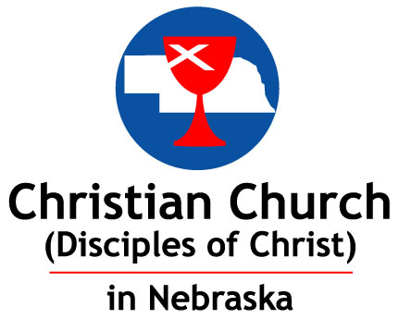
Oneness in Christ:
Finding Our Connections Through Experience & Story
2020 Virtual Regional Assembly
October 16th – 17th, 2020 (Full Schedule on Page 2)

Please use one form for each Adult

Name: Mobile Phone:

Church of Attendance/Membership:
Registration for Virtual Assembly: Attendees (Please List Each Person Attending)
Single Registration for Watch Parties/Small Groups – *see page 2 to add more names

Attendee Information: Registration Fees (1) Total Price
Adult Full Names Email Address $25
$
$ $
(Adults)
Youth Full Names (No Charge) Email Address

- Registration Fees: Hosting a virtual assembly brings cost savings in some areas, but new costs in other areas. There continues to be the cost for our keynote speaker, as well as honoraria for our preacher and guest speakers, and printing of the assembly packet that will be mailed to each church (as well as emailed to each registrant, and posted to the Region’s web site). We are also adding costs to host the virtual assembly this year, like our work with professionals in using their own equipment for recording, editing, and uploading live stream and recorded videos. Together, with each of us paying a nominal fee, we can connect with our Regional Church friends and family.

Payment (and Donations Gladly Accepted [and Desired!])
$ Registration
$ Donation

CHECKS OR CREDIT CARD: (Visa or Mastercard only)
Name As Appears on Card:

Credit Card Number:

Expiration Date: / / Security Code (three digits on back of card): _______

Mail Form and Payment to: Christian Church in Nebraska, 237 South 70th Street, Suite 221, Lincoln NE 68510

Consent for Pictures and Videos:
Declaration of consent for the use of photographs or other images: I, hereby consent to the use of my likeness and picture in photographs made for the Christian Church in Nebraska Regional Assembly, as well as in publicity concerning the same.

[ ] I consent to the use of my name in connection with the photographs, and I also allow CCN to use my name.

[ ] I do not consent to the use of my name in connection with the photographs.

SCHEDULE of EVENTS: – October 16th and 17th

FRIDAY – We Gather – The Table Is Set – 6:00 – 7:30 pm

6:00 – 6:40 pm Keynote Speaker and Dessert
Rev. Dr. Tex Sample

6:40 - 6:50 pm Break

6:50 – 7:30 pm Worship Service with Communion
Rev. Lori Tapia

SATURDAY – 9:30 am – 11:30 am/12:00 pm

9:30 – 9:40 am Welcome and Introductions

9:40 – 10:30 am Common Connections: Finding Authenticity – Dr. Kittie Grace

10:30 – 10:40 am Break

10:40 – 11:30 am Worshipful Business Session

*Additional Names for Watch Parties/Small Groups

Adult Full Name Email Address

Youth Full Name Email Address

